 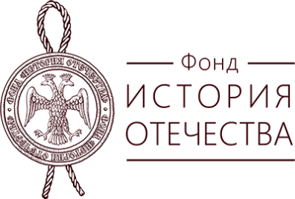

**Institute for the History of Material Culture of the Russian Academy of Sciences**

**The State Hermitage Museum**

**“History of Motherland” Fund**

invites you to take part in the

International Conference

**"Singing Arrows of Maodun: Xiongnu from Obscurity to Empire"**

dedicated to the 75th anniversary of Sergei Stepanovich Minyaev (1948‒2020).

In 2023, Dr. Sergey Stepanovich Minyaev, the outstanding researcher of the ancient cultures of Central Asia, one of the leading experts in the history and archeology of the Xiongnu would have turned 75 years old. In this regard, the Institute for the History of Material Culture of the Russian Academy of Sciences and the State Hermitage are planning to hold an international conference dedicated to a wide range of problems of Xiongnu archeology.

All specialists involved in the study of Xiongnu culture and cultures influenced by Xiongnu traditions throughout the mountain-steppe belt of Eurasia, as well as representatives of related historical disciplines and natural sciences conducting research within the framework of this issue, are invited to participate in the conference.

**The main directions of the conference:**

*– archaeological and written sources on the origins and heritage of the Xiongnu culture;*

*– problems of allocation, chronology and periodization of Xiongnu monuments;*

*– written sources and archeological data on the ritual practice of the Xiongnu;*

*– iconography of the Xiongnu artistic tradition;*

*- Xiongnu and agricultural settlements of Eurasia;*

*- agricultural settlements of the Xiongnu according to archeology and written sources;*

*- Xiongnu and ethno-cultural processes in the steppes of Eurasia at the end of the 1st millennium BC - the first half of the 1st millennium AD;*

*– interdisciplinary research in Xiongnu archeology.*

Conference time: **November 14–17, 2023**

Conference working languages: **Russian, English.**

To participate in the conference, you need to fill in the application form according to the proposed sample (Appendix 1) and to send in as an attachment to the address of the Conference Organizing Committee **conf.2023.minyaev@gmail.com** until **September 15, 2022.**

The second information letter will contain the requirements for the design of publications that are planned to be published by the beginning of the conference.

The conference and collection of papers were prepared with the financial support

of “History of Motherland” fund.

Sincerely,

Executive Secretaries of the Organizing Committee of the Conference

Varvara B. Trubnikova,

Varvara S. Busova

_____________________________________________________________________________________

**Appendix 1.**

1 Last name, first name and patronymic*.

2 Title of report* (publications).

Attention! If the report (publication) is prepared by co-authors, all of them are included in one application, while the data of each of them are given separately.

3 City, country*.

4 Official full and short name of the place of work*.

5 Position*.

6 Academic degree (if available).

7 Academic title (if any).

8 Full postal address of the place of work, indicating the number of the work (mobile) phone*.

9 Email address*.

10 Identification number in the ORCID* system.

11 Number and name of the current grant

Items marked with "*" must be filled in without fail.